**The Doel Reed Center in Taos**

Scholarships for Credit Courses

WHAT IS AVAILABLE: Several scholarships of up to $1250 are available to support students enrolled in DRC 2021 sponsored classes in Taos. You need only submit one application to be considered for all scholarships for which you are eligible.

ELIGIBILITY: Any full-time OSU student who intends to enroll in a DRC summer course and has a cumulative grade point average of 3.0 is eligible to apply. Some scholarships have additional eligibility requirements. Recipients of the Estelle Hammond Scholarship, for instance, must have completed at least 24 credit hours at OSU. The donors who funded the Dave and Louise Maher Endowed Scholarship wish to encourage Native American students to apply. Students who have a particular need for financial assistance should indicate this in their cover letters and explain their situations. Depending on funding, preference may be given to students who already have enrolled. (Students will not have to pay for DRC summer classes until after scholarship money has been dispersed.)

APPLICATION MATERIALS:

Please submit:

- A completed application form

- A cover letter that indicates briefly how taking a DRC course will benefit you and fit in with your interests/course of study; in this letter explain as well any special circumstances that necessitate your applying for financial assistance

- An unofficial transcript.

- Arrange for one faculty member to submit a letter of recommendation on your behalf.

PRIORITY DEADLINE:

To be considered for the first round of awards, make certain all the above materials of have been submitted by **5:00 p. m., Monday, April 5, 2021.**

Completed applications and letters of recommendation should be sent by email to carol.moder@okstate.edu. Be sure to put "DRC Scholarship" in the subject line.

Questions should be directed to Professor Moder at: carol.moder@okstate.edu

FINAL DEADLINE:

If funds remain after the first round, additional applications will be accepted until **5:00 PM, Friday, April 30, 2021.**

The Doel Reed Center in Taos is committed to a policy of nondiscrimination in all matters relating to admission, educational programs, activities and employment as specified by state and federal regulations and all applicable laws.

Application implies consent of the applicant to have his or her records, including transcripts, viewed by the members of the Academic Programs Committee of the Doel Reed Center in Taos

**The Doel Reed Center in Taos**

**Scholarship Application – Summer 2021**

Name:

CWID:

EMAIL ADDRESS:

DRC Course in which you are enrolling:

Major:

Total Hours completed:

Cumulative GPA:

Please Attach:

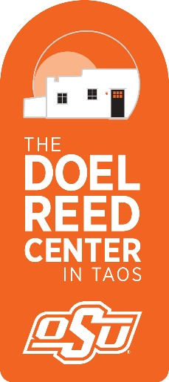1) A cover letter that indicates briefly how taking a DRC course will benefit you and will fit in with your interests and /or course of study; in this letter explain as well any special circumstances that necessitate your applying for financial assistance

2) An unofficial transcript.

In addition, please arrange for one faculty member to submit a letter of recommendation by email on your behalf.

Completed applications and letters of recommendation should be sent by email to carol.moder@okstate.edu. Be sure to put "DRC Scholarship" in the subject line.